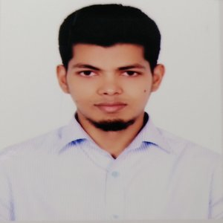
MIZANUR RAHMAN
Kallyanpur, Alamin Road
House no: 390/1, MirpurDhaka-1216
Email:mrahman5037@gmail.com
Cell Phone: +88-01515-612832

Career Objectives:
Looking for a challenging role in a reputable organization to utilize my software skills for the growth of the organization as well as to enhance my knowledge about new and emerging trends in the IT sector.
Working Experience
Assistant Programmer (03/2019 -12/2019)
On Optima Solution, Gulshan 1
- Wrote maintainable and extensible code in a team environment.
- Stored, retrieved and manipulated data for system capabilities.
- Consulted regularly with customers on project status, proposals.
- Prepared detailed reports.
- Consult with company and clients to determine user needs.
Education Qualifications
Exam Title | Concentration/Major | Institute | Result | Passing Year | Duration
Bachelor of Science (BSc) | Computer Science & Engineering | Jagannath University | CGPA:3.33  out of 4 | 2017 | 4
HSC | Science | Bangladesh Navy College | CGPA:5  out of 5 | 2011 | -
SSC | Science | Model Academy | CGPA:5  out of 5 | 2009 | -

Skills:
- Good working knowledge of PHP,Laravel framework.
- Working knowledge of Bootstrap framework, CSS3,HTML5.
- Working Knowledge of MySql.
- Working knowledge of JavaScript,jQuery ,REST API

Other Information:
Language Skill:
- Have excellent command in both English and Bengali.
Self Appraisal:
- Self-motivated, hard-working & energetic, quick learner
Personal Information:
Name : MizanurRahman
Father’s Name : Abdur Rahim
Mother’s Name : Amina Begum
Date of birth : 23/11/1994
Nationality : Bangladeshi
Permanent Address : Village:Gaoyragacha, Post: Anuhola
Sadar: TangailSadar, District: Tangail
Religion : Islam
Gender : Male
Marital Status : Married
Blood Group : B+ (positive)

Personal Interest:
- Reading book, Playing Cricket

Declaration:
I hereby declare that all the above mentioned information given by me is true and correct to the best of my knowledge and belief.

References :
Name: TanvirAhammad  Designation: Lecturer, Jagannath University  Email tanvir@cse.jnu.ac.bd  Mobile:01872222453 | Abdullah Al Mamun  Orion Group, Sr. Officer, Finance & Accounts  mamun.payroll@orion-group.net  +8801673844360

